Topic: Fraction Concepts
4 | In addition to score 3.0 performance, the student demonstrates in-depth inferences and applications that go beyond the goal.
3  Learning Goal | Students demonstrate they have the ability to:  - Understand a fraction 1/b as the quantity formed by 1 part when a while is partitioned into b equal parts. (3.NF.1)  - Understand a fraction a/b as the quantity formed by a parts of size 1/b. (3.NF.1)  - Understand a fraction as a number on the number line; represent fractions on a number line diagram. (3.NF.2)  - Express whole numbers as fractions, and recognize fractions that are equivalent to whole numbers. Examples: Express 3 in the form of 3= 3/1; recognize that 6/1=6; locate 4/4 and 1 at the same point of a number line diagram. (3.NF.3c)
2 | Students will recognize or recall specific vocabulary, such as:  - Divided, equal, fraction, number line, part, quantity, size, whole  Students demonstrate they have developed the ability to:  - Describe zero to one on a number line as one whole.  - Partition shapes into parts with equal areas. Express the area of each part of a partitioned shapes as a unit fraction of the whole. (3.G.2)
1 | Student’s performance reflects insufficient progress towards foundational skills and knowledge.

Topic: Fraction Concepts
Level 3 Item Bank
NF.2: What number is represented by the circle on the number line?  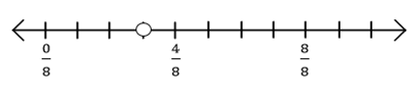 | NF.2: Lucy rode her bike around the block 4 times for a total of 1 mile yesterday. Today she wants to ride her bike $\frac{3}{4}$ of a mile. How many times will she need to ride her bike around the block?  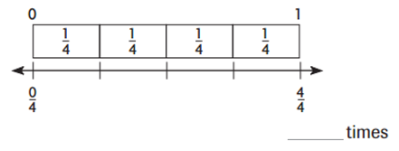 | G.2: Divide the rectangle below into four equal parts. What fraction of the rectangle is one part?
G.2: Divide each shape into the number of equal parts show. Then write the fraction that describes each part of the whole.  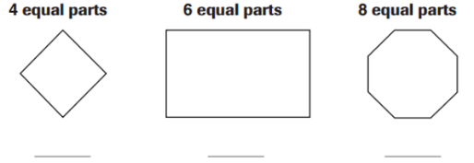 | NF.3c: Write the value of n that makes the equation true.  1 = $\frac{3}{n}$ 1 = $\frac{n}{8}$ | NF.3c: Write the value of n that makes the equation true.  6 = $\frac{6}{n}$ 3 = $\frac{n}{2}$
Level 2 Item Bank
G.2: Divide each shape into the number of equal parts shown. | G.2: Divide the rectangle below into four equal parts. |  | NF.1: The shaded part of the model shows what part of the garden is planted with peas. What fraction names the shaded part? Explain how you know how to write the fraction.  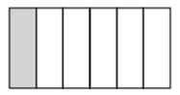
NF.1: Bailey shaded this model.
Select one number from each column to show the part of the model Bailey shaded.
