Topic: Represent and Interpret Data
4 | In addition to score 3.0 performance, the student demonstrates in-depth inferences and applications that go beyond the goal.
3  Learning Goal | Students demonstrate they have the ability to:  - Draw a scaled picture graph and a scaled bar graph to represent a data set with several categories. (3.MD.3)  - Solve two-step “how many more” and “how many less” problems using information presented in scaled bar graphs. (3.MD.3)  - Show data by making a line plot, where the horizontal scale is marked off in appropriate units – whole numbers, halves, or quarters. (3.MD.4)
2 | Students will recognize or recall specific vocabulary, such as:  - Bar graph, data, fourth, half, inch, interpret, length, line plot, picture graph, represent, scale  Students demonstrate they have developed the ability to:  - Solve one-step “how many more” and “how many less” problems using information presented in scaled bar graphs. (3.MD.3)  - Generate measurement data by measuring lengths using rulers marked with halves and fourths of an inch. (3.MD.4)
1 | Student’s performance reflects insufficient progress towards foundational skills and knowledge.

Topic: Represent and Interpret Data
Level 3 Item Bank
MD.4: Use the information from the data table to complete the line plot of worm lengths.  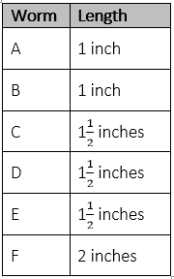  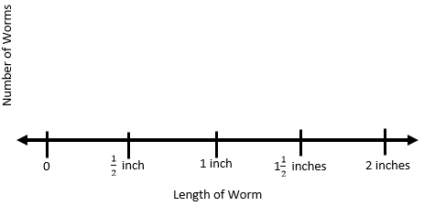  Include other opportunities with fourths. | MD.3: Ms. Green’s class is recycling bottles to help the environment. The frequency table shows the number of bottles the class recycled each week.  Part A. Use the data in the table to complete the picture graph.  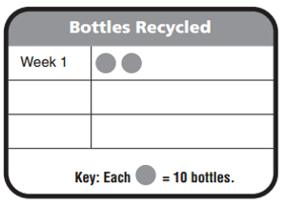  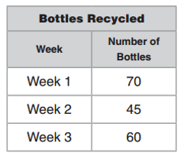 |  | MD.3: There are more students who play volleyball than play football, but fewer students play volleyball than basketball. Explain how you could change the bar graph to show the number of students who play volleyball.  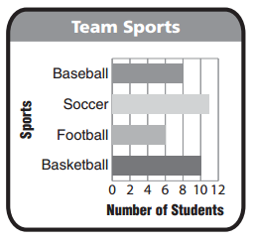
Two step word problems with information from bar graphs.
Level 2 Item Bank
MD.3: Lucy made a bar graph to show her classmates’ favorite type of movies. How many more students chose scare movies than cartoon movies?  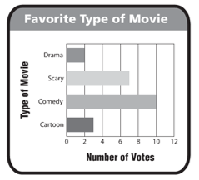 |  | MD.3: Three friends are collecting canned food for the food bank. The picture graph shows the number of cans collected so far. How many cans were collected? Explain how you found the total.  