Topic: Area
4 | In addition to score 3.0 performance, the student demonstrates in-depth inferences and applications that go beyond the goal.
3  Learning Goal | Students demonstrate they have the ability to:  - Relate area to the operations of multiplication and addition. (3.MD.7)  - Multiply side lengths to find areas of rectangles with whole-number side lengths in the context of solving real world and mathematical problems. (3.MD.7b)  - Represent whole-number products as rectangular areas in mathematical reasoning. (3.MD.7b)  - Use tiling to show in a concrete case that the area of a rectangle with whole-number side lengths a and b+c is the sum of a x b and a x c. (3.MD.7c)  - Use area models to represent the distributive property in mathematical reasoning. (3.MD.7c)  - Recognize area as additive. Find areas of rectilinear figures by decomposing them into non-overlapping rectangles and adding the areas of the non-overlapping parts, applying this technique to solve real world problems. (3.MD.7d)
2 | Students will recognize or recall specific vocabulary, such as:  - Area, decompose, distributive property, figure, length, measurement, overlap, rectangular, rectilinear, unit, tiling  Students demonstrate they have developed the ability to:  - Recognize area as an attribute of plane figures and understand concepts of area measurement. (3.MD.5)  - Measure areas by counting square units (square cm, square m, square, in, square ft, and improvised units). (3.MD.6)  - Find the area of a rectangle with whole-number side lengths by tiling it, and show that the area is the same as would be found by multiplying the side lengths. (3.MD.7a)
1 | Student’s performance reflects insufficient progress towards foundational skills and knowledge.

Topic: Area
Level 3 Item Bank
3.MD.7b  Reece is building a rectangular fort that is 4 blocks wide and 6 blocks long. How many blocks does he need? Show your thinking. | 3.MD.7c/d: Rachel uses grid paper to plan a mural to paint her school. The design will be made of two connected rectangles. The larger rectangle will have an area between 35 square feet and 45 square feet. The smaller rectangle will have an area between 10 square feet and 20 square feet. Draw and label a diagram to show what Rachel could plan. Explain how to find the total area. |  | 3.MD.7d  Determine the area of the figure below.  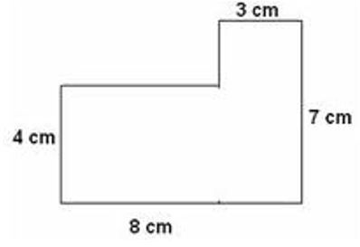
3.MD.7d
This is a diagram of a classroom. What is the area of the classroom? Explain your thinking.
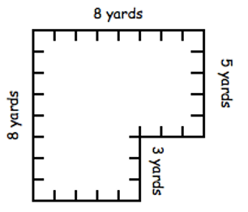
Level 2 Item Bank
3.MD.5  How would Emma find the area of a rectangle? |  | 3.MD.7a  Shade a figure with an area of 5 x 6. | 3.MD.6  Circle the rectangle with the greatest area. Note: Each unit is 1 cm long and 1 cm wide.  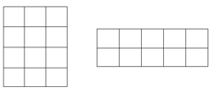  Explain how you know your answer is correct.

